- Write a definition for the following key terms and organizations in Aerospace Engineering.
Aeronautical Engineering

Astronautical Engineering

Thermodynamics

Aircraft

Spacecraft

Air Traffic Control (ATC)

Federal Aviation Administration (FAA)

National Aeronautics and Space Administration (NASA)

American Institute of Aeronautics and Astronautics (AIAA)

- For the following parts of an airplane, write a brief definition of each and then label them on a picture/sketch of a plane.
Aileron
Cockpit
Elevator
Flaps
Fuselage
Wing
Rudder
Vertical stabilizer
Horizontal stabilizer
Longitudinal Axis
Lateral axis
Vertical axis
Aileron

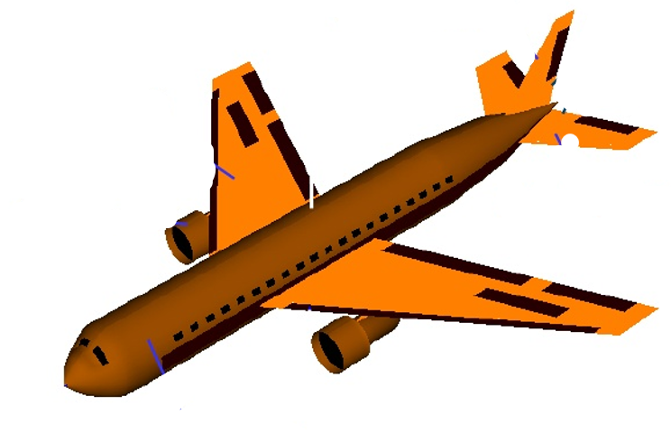

- Label the following forces and motions of an aircraft:
Yaw | Weight
Roll | Thrust
Pitch | Lift
Heading | Drag

- Write a brief explanation of the following principles as you think they are relevant to flight:
Newton’s 3rd Law of Motion

Bernoulli’s Principle

