Lab Simple Circuits – Parallel and Series Circuits

Today we will construct simple series and parallel circuits on a breadboard.
-We will also observe effect of adding energy users (resistance) and energy providers (batteries) to these circuits.

Here are examples of the two types of simple circuits. The series circuit has the battery and two bulbs in one loop. The parallel circuit has the battery and each bulb in its own loop.

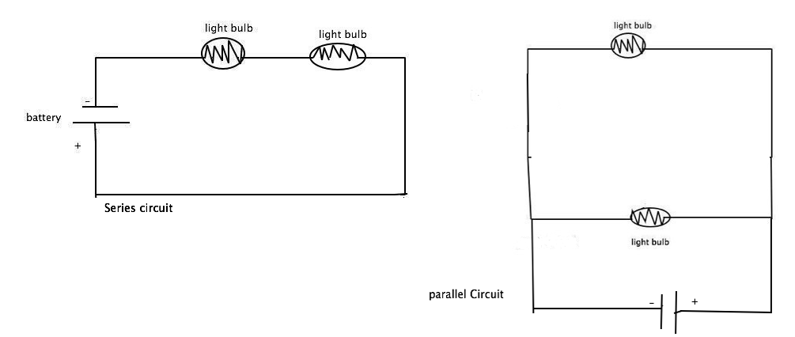

***Notes about bulbs: the light bulbs in these diagrams have an internal resistance unlike our LED’s. To account for this, we will use soldered pairs of LED’s and resistors to represent each bulb, looking like this:

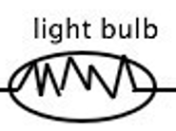
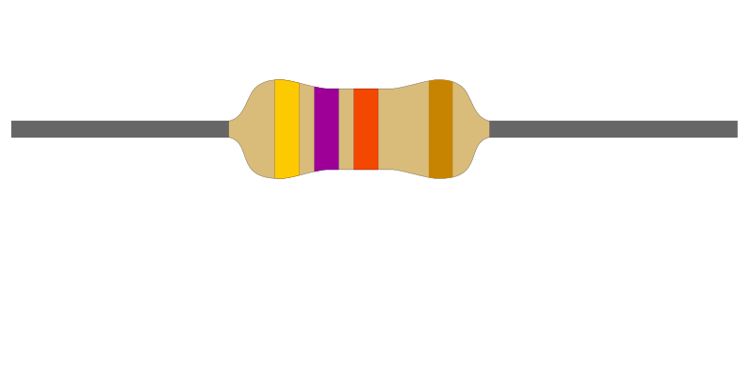

-
+

***Additional note about the LEDs: LEDs are directional in how they are connected, meaning it matters which part of the LED is wired to positive and negative. In most cases, the longer lead (wire coming out of the LED) should be connected to the positive end.

Series Circuit

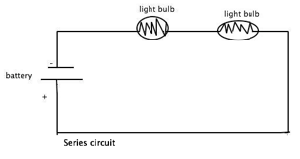
- Construct the series circuit. Measure the resistances and voltages for the individual resistors+LEDs used as well as for the entire circuit. Compare these values to the theoretical values.

1a. Measured (Experimental) values  R_{total} = XXXXXX V_{total} =  R₁ = V₁ =  R₂ = V₂ = | 1b. Theoretical (calculated) values  R_{total} = V_{total} = XXXXXXX  R₁ = XXXXXX V₁ = XXXXXX  R₂ = XXXXXX V₂ = XXXXXXX

- Add another resistor in series to the two series bulbs (so altogether there are three resistors and two LEDs in series). Add power to this circuit. What happens to the bulbs compared to the previous circuit? Explain why based on how voltage, current and resistance are affected in a series circuit.

- What will happen to this circuit if one LED/resistor pair is removed?

- Explain your observations based on how voltage, current, and resistance are affected in the series circuit.

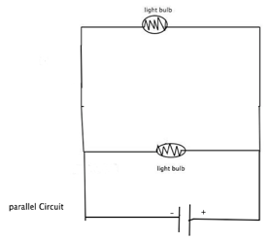
Parallel Circuit

- Construct the parallel circuit. Measure the resistances and voltages for the individual resistors+LEDs used as well as for the entire circuit. Compare these values to the theoretical values.

5a. Measured (Experimental) values  R_{total} = XXXXXX V_{total} =  R₁ = V₁ =  R₂ = V₂ = | 5b. Theoretical (calculated) values  R_{total} = V_{total} = XXXXXXX  R₁ = XXXXXX V₁ = XXXXXX  R₂ = XXXXXX V₂ = XXXXXXX

- Add another resistor in parallel to the two parallel bulbs (so altogether there are three resistors and two LEDs in parallel). Add power to this circuit. What happens to the bulbs compared to the previous circuit? Explain why based on how voltage, current and resistance are affected in a parallel circuit.

- What will happen to this circuit if one LED/resistor pair is removed?

- Explain your observations based on how voltage, current, and resistance are affected in this circuit.

