**Electrical Engineering Lab 1 – Voltage Division Discovery**

**OBJECTIVES**

* To deepen our understanding of Ohm’s law and series and parallel circuits
* To practice our familiarity and experience with basic electronics lab equipment (multimeter, power supply, breadboard)
* To learn the limits of the operation of components and equipment
* To learn how to build a circuit from a schematic
* To practice recording data and experimental results as a means of effectively communicating your learning
* To demonstrate best safety practices
* To discover the principals of voltage division

**INTRODUCTION**

**Breadboard Description**

Most of the circuits built and tested in this laboratory will be assembled on a “breadboard,” which looks like a piece of plastic with holes in it, as shown in Figure 1. Electrical components (resistors, capacitors, wires, etc.) are inserted into the holes. What makes a breadboard unique is that certain combinations of the holes are electrically connected with each other. These connections are hidden inside the plastic. Thus, a user must know which holes are connected. Most breadboards have a similar pattern of interconnections.

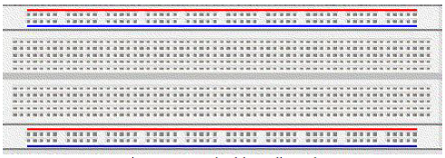

**Fig. 2** – A typical breadboard.

**Breadboard Connections:**

The internal connections inside the breadboard run in both vertical and horizontal lines, as shown in Fig. 2. Some important facts about breadboards are The vertical connections are in groups of five. Each of the group of five holes are connected. Each horizontal row has all its holes connected No column is connected to any other column, no row is connected to any other row, and no column is connected to any row. The spacing between adjacent holes in a row (or column) is 0.1 inch.

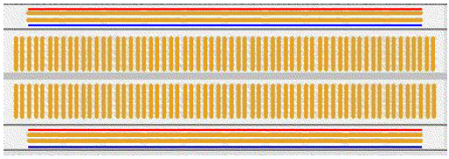

**Figure 3** – The hidden connections of the breadboard of Figure 2.

Separate components are connected at one point (called a node) by inserting the proper component(s) into the proper breadboard holes. The advantage of using a breadboard is that relatively large circuits can be assembled neatly without having a maze of interconnecting wires. Further, when connections must be made from the assembled circuit to external equipment, such as power supplies and meters, leads with alligator clips on one or both ends can be used.

The alligator clips are connected directly to the circuit components. A circuit should be assembled and checked before any external connections are made.

**Variable Power Supply and Ground**

The DC power supply used in our class is to Each power supply is internally grounded. This means that the low side of the voltage source is connected to ground and is inaccessible inside the ELVIS unit. Do **not** to ground the power supply. Connecting ground directly to the output of the power supply will blow a fuse (and hurt your grade). A typical circuit starts at “Supply +,” goes through a network of resistors and possibly other components and returns to ground. This is a closed circuit because it starts at ground (inside the power supply) and returns to ground.

**Digital Multimeter (DMM)**

A DMM is a multipurpose tool for measuring circuit values such as voltage, current, and resistance. A voltage measuring device is called a voltmeter. To measure voltage, attach the red lead of the DMM to the port on the right side, labeled *V*, and select *VDC* with the knob. Measure voltage by attaching the leads of the DMM to the terminals of desired element. Be sure to maintain the sign convention of the circuit diagram. Attach the red lead to the point on the circuit marked with a *+* symbol and the black lead to the point with – symbol. In Fig 6, we are attempting to measure VOUT, the voltage across resistor R2.

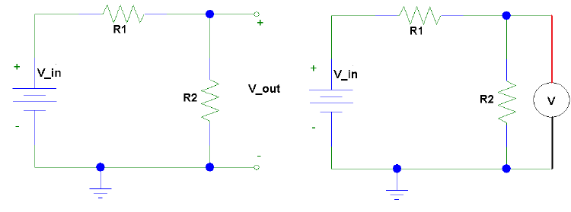

**Figure 6:** The circuit on the left shows the voltage, VOUT, to be measured. The circuit on

the right shows the connections for the DMM.

A current measuring device is known as an ammeter. To put the DMM in ammeter mode, attach the red lead to the left side port of the meter, and select *IDC* with the knob. There are two ports for current, which differ in the maximum current they can measure. If you try to measure a current that is too large for the port, the fuse will blow. The fuse values are labeled on the DMM. To measure current, break the circuit open where the current is to be measured and insert the meter to re-close the circuit. In Fig. 7, we are attempting to measure the series current, I.



**Figure 7:** The circuit on the left shows the current, I, to be measured. The circuit on the right

shows the connections for the DMM. Notice the sign convention for current measurement.

**Short Circuit**

An element is short circuits (shorted) when its terminals are connected, usually with a piece of wire (but a metal ring or bracelet will do just as well). When a resistor (or any other device) is short circuited, current will completely bypass the resistor because the short circuit provides a more desirable path since a short circuit has zero resistance. Fig. 8 shows a short-circuited resistor. Avoid short circuits in your circuits.



**Figure 8**: A resistor (left) and a short-circuited resistor (right).

**Series and Parallel Resistors**

When resistors are connected in series (as shown in Fig. 9), the terminal of one resistor is connected directly to the terminal of the next resistor, with no other possible paths. When resistors are in series, they are equivalent to a single resistor with a resistance equal to the sum of the series resistances, i.e.,

*RSERIES = R1 + R2 + R3 + …*

**

**Figure 9:** Series resistors, *RSERIES = R1 + R2 + R3 + …*

When resistors are in parallel (as shown in Figure 10), all of their first terminals are connected together, and all of their second terminals are connected together. When resistors are in parallel, they are equivalent to a single resistor whose value is given by the following equation:

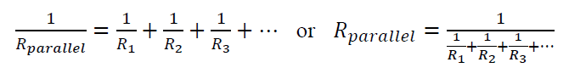

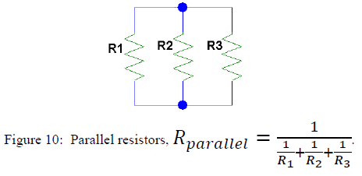

Name(s): ____________________

**Electrical Engineering Lab 1 – Voltage Division Discovery**

**Pre-Lab Questions**

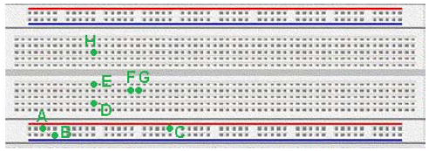

1. A resistor is placed on the breadboard above between two of the marked points. State whether the resistor is shorted (terminals of the resistor are connected) or if its terminals are unconnected.
   1. Resistor between A and B.
   2. Resistor between A and C.
   3. Resistor between D and E.
   4. Resistor between E and H.
2. Two resistors are placed on the breadboard above. State whether the two resistors are connected in parallel, in series, or not connected.
   1. First resistor between D and F. Second resistor between G and H.
   2. First resistor between C and D. Second resistor between E and H.
   3. First resistor between A and D. Second resistor between C and E.

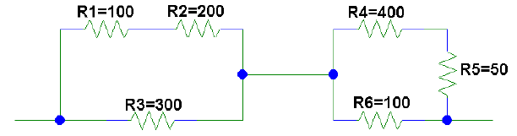

**Figure 11:** Resistor network for problem 3. All values in ohms.

1. Answer the following questions about the resistor network of Fig. 11
   1. Are any of the six labeled resistors in parallel? If so, which ones.
   2. Are any group(s) of resistors in series? If so, which ones. If so, simplify the circuit by reducing all series connections. Draw the new circuit and label all resistor values.
   3. How many groups of parallel resistors are in the simplified network from (b)?
   4. Reduce the entire network to a single resistor. What is the equivalent resistance for the circuit of Fig. 11?

**LAB PROCEDURE AND QUESTIONS PART I**



**Figure 12:** The voltage supply value is in volts and the resistance values are in ohms.

1. Set up the series circuit in Fig. 12. Use the variable power supply and remember to return the circuit to ground.
2. What is the theoretical value that you expect for V2? Measure the voltage V2 with the DMM. Why don’t they match?
   1. Theoretical value:
   2. Actual value:
   3. Why don’t they match?
3. What is the theoretical and actual value of the voltage of the point between R1/R2 and ground?
   1. Theoretical:
   2. Actual:
   3. How is this value related to the voltage at point 2 and the voltage of the power supply?
   4. If you had a 5 Volt battery but wanted 3 volts, how could this principal help you (draw or explain a circuit)
4. What is the theoretical value that you expect for the current in the circuit? Measure the current with the multimeter. ASK ME ABOUT MEASURING CURRENT BEFORE YOU DO IT! IF YOU’RE NOT CAREFUL YOU CAN BREAK MY METER!!!
   1. Theoretical value:
   2. Actual value:
   3. Why don’t they match?
5. Is Ohm’s Law satisfied for R3? Explain.
6. Replace the three series resistors with a single resistor, RSERIES, of equal value. Measure the current through this resistor. Is the current equal to the current in the original circuit? If not, why not?
7. Measure the voltage across RSERIES.
8. Is Ohm’s Law is satisfied for the new resistor? Explain.

**LAB PROCEDURE AND QUESTIONS PART II**

1. Design a circuit which provides a 1.5V, 3V and 5V power source. Draw the schematic below:
2. Build this circuit on your breadboard using resistors as close to the actual value you can. Redraw your schematic using the MEASURED values of resistors you used.
3. Complete the table below of your theoretical and actual voltages. If there is a difference, why do you think this is?

|  |  |  |
| --- | --- | --- |
| Ideal voltage | Theoretical voltage with measured values | Actual measured voltage |
| 1.5 V |  |  |
| 3 V |  |  |
| 5 V |  |  |

1. How much current is drawn from your circuit?
   1. Theoretical:
   2. Actual:
2. How can you modify your circuit to draw more current?