- Engineering Design Process
- Define the Problem:
Words words words
- Do Background Research:
Words words words
- Specify Requirements:
Words words words
- Brainstorm Solutions:
Words words words
- Choose a Solution:
Words words words
- Do Development Work:
Words words words
- Build a Prototype:
Words words words
- Test and Redesign:
Words words words
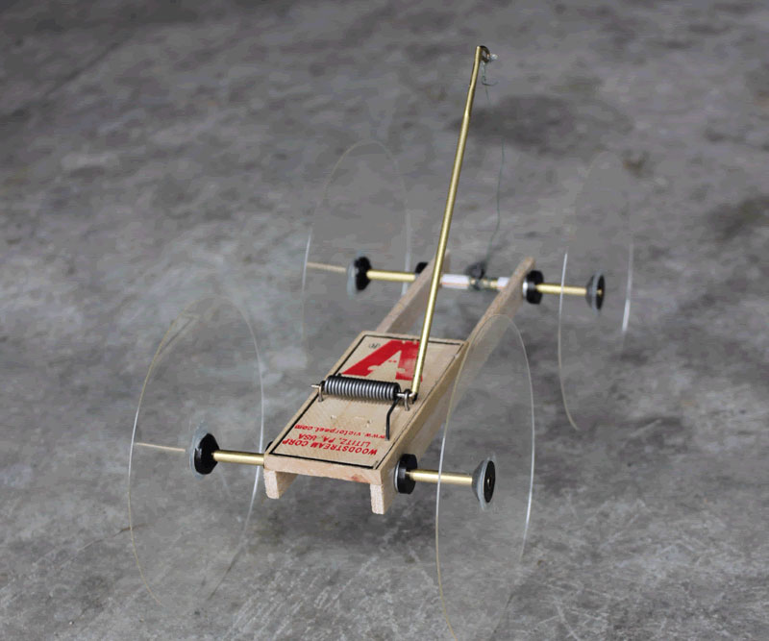
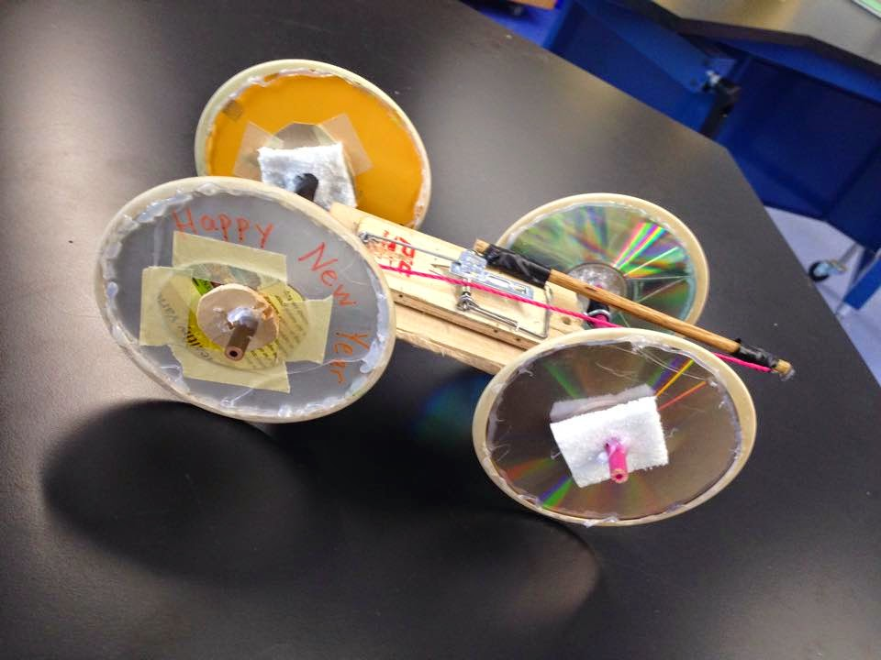

- How did your vehicle do?

- How did what you know about Mechanical Engineering apply to this project?

- If you were to do this project again, what would you do differently?

