Page 1 – put the appropriate view (A-F) under each view
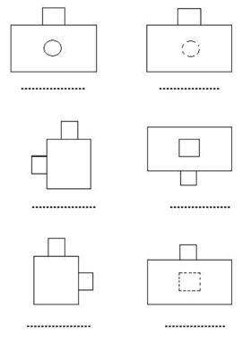
Page 2 –Match the view sections (a-g) with the surfaces (1-7)
A | B | C | D | E | F | G

Page 3 – Label each view (front/side/top)
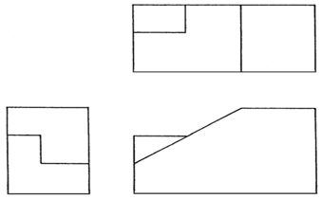
View: _________
View: _________
View: _________

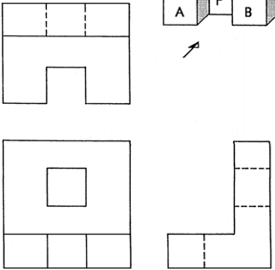
View: _________
View: _________
View: _________

Page 4 – Match the orthographic views (1-18) with the views
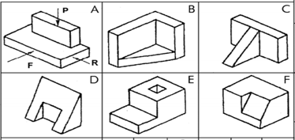
Drawing | A | B | C | D | E | F
FRONT view in direction of F | 10
PLAN view in direction of P
SIDE view in direction of R

Page 5 – Match the orthogonal with the isometric view
1 | 2 | 3 | 4 | 5 | 6 | 7 | 8 | 9 | 10

Page 6 – Match the oblique with the orthogonal view
A | B | C | D | E | F | G | H | I | J

Page 7 – Match the isometric with the isometric view
A | B | C | D | E | F | G | H | I | J

Page 8 – Match the orthogonal with the isometric view
1 | 2 | 3 | 4 | 5 | 6 | 7 | 8 | 9 | 10

Page 9 – Match the orthogonal with the isometric view
1 | 2 | 3 | 4 | 5 | 6 | 7 | 8 | 9 | 10

Page 10– Create an orthogonal sketch (front, side, top) of the object below
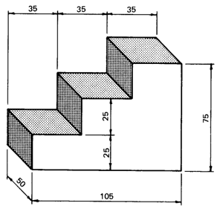
Top View
Front View
Front View

Page 11 – Create an orthogonal sketch (front, side, top) of the object below
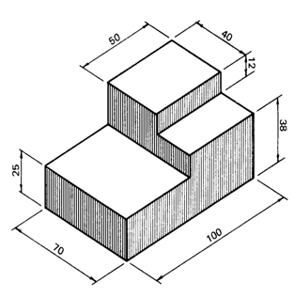
Front View
Top View
Front View

