To answer the following questions, go to the Arduino C/C++ tutorial on the following link: https://startingelectronics.org/software/arduino/learn-to-program-course/introduction/

- Part 1
  - What is a function?
Click or tap here to enter text.

  - What does compiling code do?
Click or tap here to enter text.

  - What is the purpose of the Serial Monitor Window?
Click or tap here to enter text.

  - What is the purpose of the curly brackets? (these guys: {} )
Click or tap here to enter text.

  - What is the purpose of the semicolon? (“;”)
Click or tap here to enter text.

  - How could you modify the code so the Serial Monitor Window shows a message other than “Hello, World!”?
Click or tap here to enter text.

  - How could you modify this code so that it printed “Hello, World” (or some other message) more than just once? Attach a screenshot of either your code or your serial monitor window
Click or tap here to enter text.

Part 2
  - The default Arduino File has two functions, a setup and a loop. What is the purpose of the setup function and the loop function?
Click or tap here to enter text.

(No screenshot of your code or monitor window needed for this part)

Part 3
  - What is the purpose of a variable?
Click or tap here to enter text.

  - Is it necessary for some lines of code to be indented and others not?
Click or tap here to enter text.

  - What is the difference between an integer (int) and floating (float) variable?
Click or tap here to enter text.

  - Will the following code work? If not, then why?
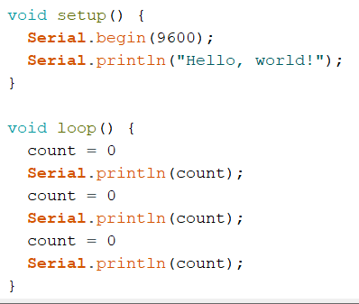
Click or tap here to enter text.

Part 4
- What is the difference between doing arithmetic with floating and integer variables?
Click or tap here to enter text.

- What is the difference between the “print” and “println” commands?
Click or tap here to enter text.

- Create your own unique code file which demonstrates the functionality of addition, subtraction, multiplication, division, and remainder for both integer and floating variables. Copy a screenshot of your code below.
Click or tap here to enter text.

- Have me check off your code. CHECK OFF #1

