To answer the following questions, go to the Arduino C/C++ tutorial on the following link: https://startingelectronics.org/software/arduino/learn-to-program-course/introduction/

Part 5
- What is the difference between what will be printed in the serial monitor window between these two code samples?
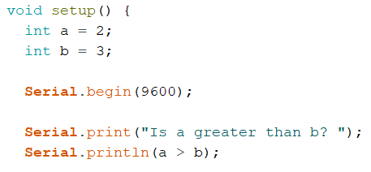 | 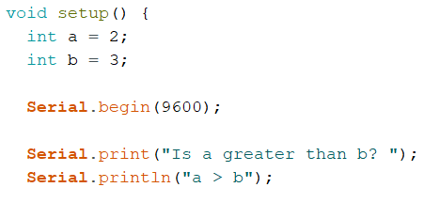

Click or tap here to enter text.

- If a=2, b=3, c=5, and d=3, what would the following printed result be (what appears in the Serial Monitor Window) for the following lines of code?
  - Serial.print(a < 2);
Click or tap here to enter text.
  - Serial.print(b >= d);
Click or tap here to enter text.
  - Serial.print(a == d);
Click or tap here to enter text.
  - Serial.print(c > (a+b));
Click or tap here to enter text.
  - Serial.print(A == 2); //(*hint hint* it’s a capitol A)
Click or tap here to enter text.

Part 6
- For each of the following lines of code, what is the final value of count?
- 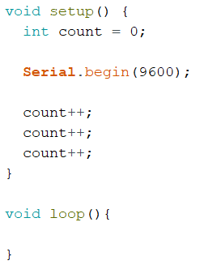 | - 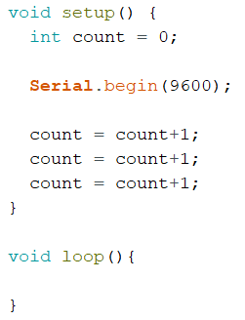

Click or tap here to enter text.

- C and C++ are both very similar languages. The main distinction is that C was developed first in the 70’s, and then C++ was developed ~ 5-10 years later as an updated version. One of the key updates was a feature to make writing “variableName++” act the same as “variableName = VariableName + 1” (which is where C++ got its name). What do you think the purpose to this update was?
Click or tap here to enter text.

Part 7 & 8
- Label the parts of the for loop
Click or tap here to enter text.

Click or tap here to enter text.

Click or tap here to enter text.

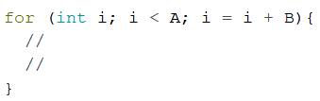
Click or tap here to enter text.

Click or tap here to enter text.

- Label the parts of the while loop
Click or tap here to enter text.

Click or tap here to enter text.

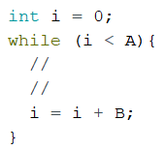
Click or tap here to enter text.

Click or tap here to enter text.

- What is the difference between for loops and while loops? When might you want to use one versus the other?
Click or tap here to enter text.
- What would the final value of I be for the following code?
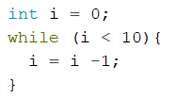 Click or tap here to enter text.

