Write a BRIEF definition for each of the following terms relevant to Computer Engineering:
- ADC:
- PWM:
- Microcontroller:
- Arduino:
- Computer:
- LED:
- Servo:
- High-Level coding:
- Low-level coding:
- Serial-Monitor Window:
- Syntax (remember, I want a coding definition for syntax ):
- C/C++
- Compile (remember, I want a coding definition for compile ):
- Function (remember, I want a coding definition for function ):
- Script (remember, I want a coding definition for script ):
- Float vs integer variables:

Binary – Converting to ASCII and 8-bit/10-bit conversion
- What is the ASCII value of 48?

- What is the ASCII value of 65?

- The maximum 10 bit binary number is 11111111 and has a decimal value of 1024. What is the maximum 8 bit binary number and its corresponding decimal value?

ADC and PWM questions:
- What does ADC stand for?

- What does PWM stand for?

- As it relates to inputting/outputting info from a microcontroller, when are ADC and PWM used?

- The Arduino code command for ADC is:

- The Arduino code command for PWM is:

- Remember that Arduino’s ADC converter is 10-bit and PWM is 8-bit (meaning ADC has 10 bits of 0/1’s and PWM has 8 bits of 0/1’s).
  - If the Arduino is to read an ADC value of 100 from a voltage source, what PWM value would it need to output to produce the same value voltage?

  - If the Arduino is to read an ADC value of 1023 from a voltage source, what PWM value would it need to output to produce the same value voltage?

- You wish to make a 5 volt motor move at half speed. First you could connect the motor’s wires to pin 11 and ground on the Arduino Uno and then write what line of code: (Assume any setup lines of code are already written in the script)
  - analogRead(512);
  - analogWrite(11, 512);
  - anaogRead(11,125);
  - analogWrite(11, 125);

- You wish to turn an LED connected to pin 11 on to 1/4 brightness for one second, then off for a second, then full brightness for one second, then off for a second. Which of the following code blocks could accomplish this?
a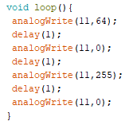 | b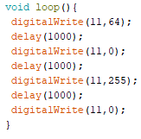
c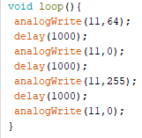 | d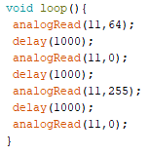

- You wish to turn to read a voltage from a sensor. To do this, you could first connect the sensor to a ground pin and pin A3 on the Arduino Uno and then write which of the following lines of code?
a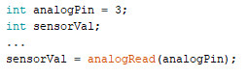 | b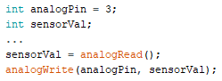
c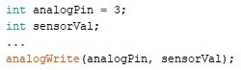 | d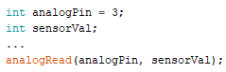

Matching – Match the coding term with the code blocks which best demonstrates its execution:
A..
 | - For Loops: ______ | - While Loops: ______ |  | - Conditional Statements: _______ | - Logical  Operators: ______
 |  | B.. |  | C..
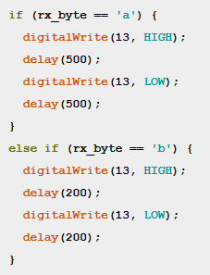  D.. |  |  | 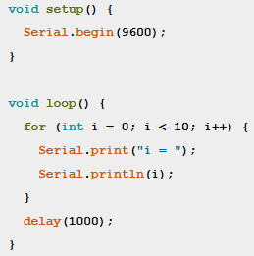 |  |  | 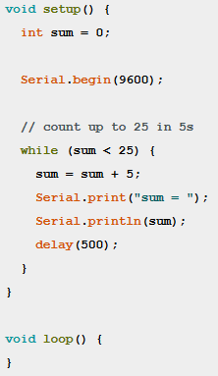
 |  |  | 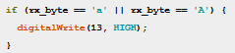
Logical & Conditional Operations – For each of the logical operations, state what the final value of the variable n is:
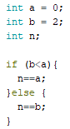  - The final value of n is: _____ | 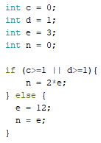  - The final value of n is: ______

For the four following code blocks, three do not compile. Identify which of the four is the code which DOES compile and for the three which do not compile, why.
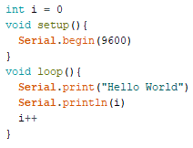  - Does this code compile? If not, why? | 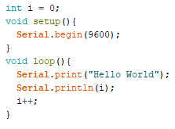  - Does this code compile? If not, why?
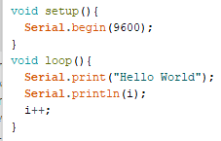  - Does this code compile? If not, why? | 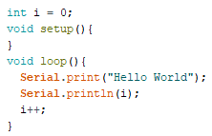  - Does this code compile? If not, why?

- Write a code script which does one of the following: (This will be a bonus question)
- Reads a voltage from an analog sensor and then prints this value into the Serial Monitor Window.
- Turns an LED either on or off depending on what key(s) you press on the computer keyboard

